Applied Databases Topic 6 Exercise Sheet

1. Create a mongodb database called usersdb.



2. Create a collection called users which has documents with the following attributes:

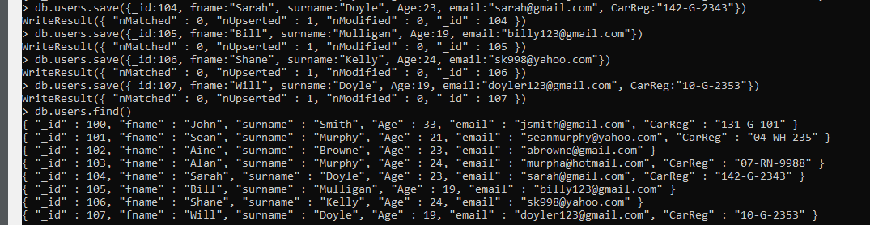

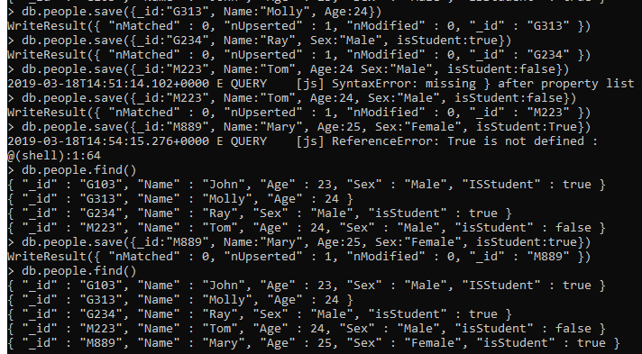

|  |  |  |  |  |  |
| --- | --- | --- | --- | --- | --- |
| _id | fname | surname | age | email | Car Reg |
| 100 | John | Smith | 33 | jsmith@gmail.com | 131-G-101 |
| 101 | Sean | Murphy | 21 | seanmurph@yahoo.com | 04-WH-235 |
| 102 | Aine | Browne | 23 | abrowne@gmail.com |  |
| 103 | Alan | Murphy | 24 | murpha@hotmail.com | 07-RN-9988 |
| 104 | Sarah | Doyle | 23 | sarah@gmail.com | 142-G-2343 |
| 105 | Bill | Mulligan | 19 | billy123@gmail.com |  |
| 106 | Shane | Kelly | 24 | sk998@yahoo.com |  |
| 107 | Will | Doyle | 19 | doyler123@gmail.com | 10-G-2353 |

3. Give the command to find all documents in the users collection.

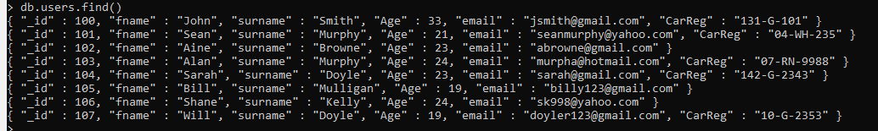

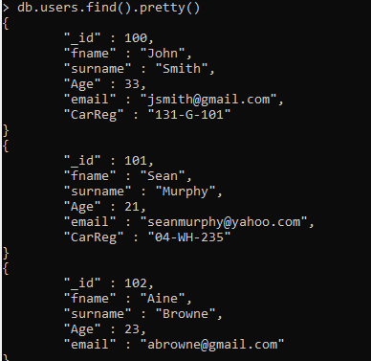

4. Give the command to find all documents in the users collection where the age is 19.



5. Give the command to find all documents in the users collection where the age is greater than 19.

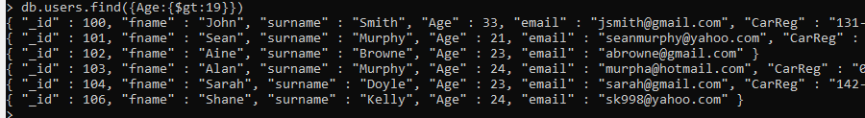

6. Give the command to find all documents in the users collection where the age is greater than 19 and the user has a car.



7. Give the command to find all documents in the users collection where _id is greater than 104 and age is greater than 20.



8. Give the command to find the first document in the users collection where the user has a car.

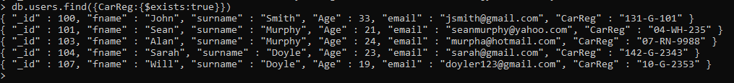

9. User 106 - Shane has bought a car with reg 12-G-1234. The following command was run to update the user’s document: db.users.save({_id:106, carReg:"12-G-1234"}) What does the document look like now and why?

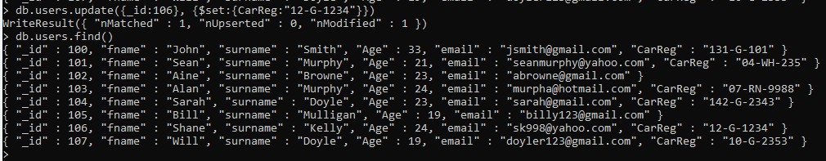

10. User 102 - Aine has bought a car with reg 10-G-9876. The following command was run to update the user’s document: db.users.update({_id:102}, {carReg:"10-G-9876"}) What does the document look like now and why?

**The whole line has been updated to just show a CarReg**

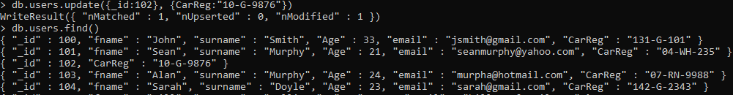

11. User 105 – Bill’s document is as follows: { "_id" : 105, "fname" : "Bill", "surname" : "Mulligan", "age" : 19, "email" : "billy123@gmail.com" } Bill has bought a car with reg 161-MO-4. Give the command so that Bill’s document now looks as follows: { "_id" : 105, "fname" : "Bill", "surname" : "Mulligan", "age" : 19, "email" : "billy123@gmail.com", "carReg" : "161-MO-4" }

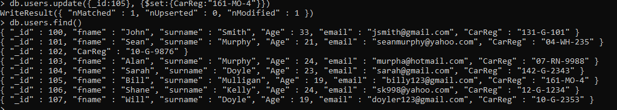

12. User 106’s document now looks as follows: { "_id" : 106, "carReg" : "12-G-1234" } Give the command to add the original fields: _id fname surname Age email 106 Shane Kelly 24 sk998@yahoo.com back to the document in a single command so that the document now looks as follows: _id fname surname Age email carReg 106 Shane Kelly 24 sk998@yahoo.com 12-G-1234

**!!!!Check!!!! order is wrong way around**

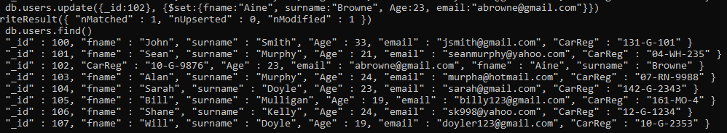

13. Give the mongodb command to add 1 to each user’s age.

14. Add a new attribute sex, to each document as follows:

|  |  |
| --- | --- |
| _16 | Sex |
| 100 | M |
| 101 | M |
| 103 | M |
| 104 | F |
| 105 | M |
| 106 | M |
| 107 | M |

15. Add a new attribute title with the value Mr., to each document where the sex is M, and the age is greater than 20:

16. Users 101 – Sean, 103 – Alan and 107 – Will have sold their cars, update the collection to remove the carReg attribute from these documents.

17. Give the mongodb command to list/show only the fname, surname, age and sex attributes of documents where the _id is between 101 and 107 inclusive.

18. Give the mongodb command to renme the fname attribute to Name.